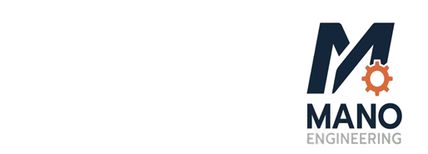
MANO ENGINEERING LLC
2512 Northland Drive
Mendota Heights, MN 55120

Employment Offer Letter

Dear Mr. Khongmeng Kormoua
We are pleased to offer you a full-time position (40 hours per week) with Mano Engineering LLC as an Electrical Engineer, beginning on or around 3/16/2026. Your base compensation will start at $17.5 per hour.
Position Overview:
The position will support Mano Engineering LLC’s product development and testing by contributing to design and evaluation of system and product, technical analysis and engineering documentation. This role involves collaborating with cross-functional teams to develop and improve products while ensuring designs meet technical requirements and manufacturing standards.
For this role, your major responsibilities will be:
- Develop technical knowledge of competitive products and systems to enable product solutions
- Maintain up-to-date general industry knowledge
- New product development, design and testing
- Create schematics, drawings, and technical documentation
- Modifications of existing products per customer requirements
- Participating in design reviews
- Support the transfer of designs to manufacturing
- Working collaboratively with mechanical, designers, product management, purchasing and manufacturing
- Build and strengthen relationships with key clients and vendors
- Must have good communication and interpersonal skills.
You will be working at our 2512 Northland Drive, Mendota Heights, MN 55120 office and will be reporting directly to Giri Addagudi.
Please confirm your acceptance of this offer by signing and returning a copy of this letter by 3/13/2026
We are excited to welcome you aboard and look forward to your contributions to our continued success. If you have any questions, feel free to contact Giri Addagudi.
Sincerely,
Giri Addagudi
CEO
Mano Engineering LLC
giridhar@manoengineering.com
651-705-0162

Giridhar Addagudi

Signature: _________________________

Date: _____________________________
Khongmeng Kormoua

Signature: _________________________

Date: _____________________________

